

Site Genesis payment cartridge

integration

## int_checkoutcom | Version 22.1.0



**Table of Contents**

1. Summary 1-3
2. Component Overview 2-4
   1. Functional Overview 2-4
   2. Use Cases 2-4
   3. Limitations, Constraints 2-4
   4. Compatibility 2-4
   5. Privacy, Payment 2-4
3. Implementation Guide 3-5
   1. Setup 3-5
   2. Configuration 3-5
   3. Custom Code 3-5
   4. External Interfaces 3-5
   5. Testing 3-5
4. Operations, Maintenance 4-6
   1. Data Storage 4-6
   2. Availability 4-6
   3. Translation 4-6
   4. Support 4-6
5. User Guide 5-7
   1. Roles, Responsibilities 5-7
   2. Business Manager 5-7
   3. Storefront Functionality 5-7
6. Known Issues 6-8
7. Release History 7-9

# 1. Summary

Checkout.com is a software platform that has integrated 100% of the value chain to create payment infrastructures that truly make a diﬀerence. Checkout.com is authorised and regulated by the Financial Conduct Authority under the Electronic Money Regulations 2011 (reference number 900816) to issue electronic money and provide payment services.

The Checkout.com cartridges allows Salesforce Commerce Cloud (SCC) store owners to process payments through the Checkout.com Payment Gateway.

This implementation guide describes how to integrate the Checkout.com Site Genesis payment cartridge into an SFCC reference application. The integration is cross-browser, cross-device compatible, and can accept online payments from all major credit cards.

The Checkout.com LINK cartridge package contains 3 folders:

1. **int_checkoutcom -** Site Genesis integration for the checkout.com payment gateway
2. **int_checkoutcom_sfra -** SFRA integration for the checkout.com payment gateway
3. **bm_checkoutcom -** BM integration for the checkout.com payment gateway

These integrations have been designed using Javascript Controllers and don’t contain any deprecated Pipelines code. For a maximisation of the conversion rate, the buyer is not redirected to third party sites during the payment process. Consequently, the shop operator does not need a PCI DSS certification to use the solution.

In order to test or eﬀectively process payments through the Checkout.com Payment Gateway, you will need to open an account. Please contact your Checkout.com account manager or send an email to [support@checkout.com](mailto:support@checkout.com) for more information.

# Supported Payment Methods

The Checkout.com SFRA cartridge for SFCC provides support for the following payment methods

⦁ Credit cards – Accept all major credit and debit cards including Visa, Mastercard, AMEX, Diners, Discover and more

⦁ AliPay

⦁ ApplePay

⦁ Bancontact

⦁ BenefitPay

⦁ Boleto

⦁ EPS

⦁ Fawry

⦁ GiroPay

⦁ GooglePay

⦁ iDEAL

⦁ Klarna

⦁ KNET

⦁ MADA

⦁ MultiBanco

⦁ P24

⦁ PayPal

⦁ Poli

⦁ QPay

⦁ Sofort

⦁ SEPA

⦁ Oxxo

# Supported Payment Types

⦁ Cards

⦁ Wallets

⦁ Cash and ATM payment

⦁ Bank Transfer

⦁ Direct Debit

⦁ Invoice and pay later

1. **C****omponents Overview**

* 1. **Functional Overview**

The Checkout.com Site Genesis cartridge for SFCC connects your online store with the Checkout.com gateway and automates all payment processes, delivering a comprehensive payment integration with simple usability and maximum performance.

* Consolidated expertise for all payment methods and services
* End-to-end automation of all payment processes
* Seamless integration into the SCC checkout process
* Central administration directly in the SCC backend
* No PCI DSS certification necessary for you as a merchant
* Fast time-to-market due to the use of scalable cloud technologies

The following features are available directly through the SCC Business Manager and the Hub, Checkout.com’s payment management backend:

* Fully featured transaction management: handle authorisation, capture, void, full or partial refund, blacklisting and chargebacks
* Customer/Card holder details, cards and address management
* Integrated risk engine with handling of fraud prevention

Checkout.com’s Site Genesis cartridge for SFCC allows shoppers to perform secure payments without leaving the store and gives store owners a full control over payments and customer management.

The payment workﬂow can be summarised into 3 steps:

* Display a payment form
* Submit the form, charge the customer for the total amount of the order, handle the response
* Display the order confirmation page or the cart with an error message in case of failure

∙

Upon completion of a payment, detailed information about the order and the corresponding transactions are available in the order details in the SFCC Business Manager.

* 1. **Use Cases**

There is currently a single use case for this cartridge: the shopper is using one of the Checkout.com payment methods to complete a purchase on an SFCC website:

1. On the billing checkout step, a payment form is displayed
2. The shopper provides payment details and places an order
3. In case of payment success, the shopper is redirected to the order confirmation page
4. In case of payment failure, the shopper is redirected to the cart and can try again Please see section **5.3 Storefront functionality** for images of the payment process**.**

* 1. **Limitations, Constraints**

1. The Checkout.com Site Genesis cartridge integration doesn't support multi-shipping and subscriptions.
2. The Checkout.com Site Genesis payment form is not compatible with the default Site Genesis credit card form. The default Site Genesis should be disabled when the Checkout.com payment form is enabled.

* 1. **Compatibility**

Available since Site Genesis v105.2.0 Compatibility Mode 21.7

* 1. **Privacy, Payment**

This integration requires access to the following customer data elements:

* Card Details
* Billing Address
* Shipping Address
* Order Details
* Customer Profile
* Some custom properties of Customer Payment Instruments.

# Implementation Guide

* 1. **Setup**

The Checkout.com Site Genesis integration is contained in the storefront cartridge **int_checkoutcom**. This single cartridge contains all the payment processor integration functionalities. The integration is compatible with storefronts based on Javascript Controllers.

The **int_checkoutcom** cartridge folder contains the following files:

**CONTROLLERS & PROCESSORS**

* controllers/CKOMain.js
* controllers/CKOKlarna.js
* controllers/CKOSepa.js
* controllers/COPlaceOrder.js
* scripts/payment/processor/CHECKOUTCOM_APM.js
* scripts/payment/processor/CHECKOUTCOM_APPLE_PAY.js
* scripts/payment/processor/CHECKOUTCOM_CARD.js
* scripts/payment/processor/CHECKOUTCOM_GOOGLE_PAY.js

**FORMS**

* forms/default/alternativePaymentForm.xml
* forms/default/applePayForm.xml
* forms/default/cardPaymentForm.xml
* forms/default/googlePayForm.xml
* forms/default/sepaForm.xml

**HELPERS**

* scripts/helpers/apmHelper.js
* scripts/helpers/applePayHelper.js
* scripts/helpers/cardHelper.js
* scripts/helpers/ckoHelper.js
* scripts/helpers/googlePayHelper.js
* scripts/helpers/eventsHelper.js
* scripts/helpers/sensitiveDataHelper.js
* scritps/helpers/transactionHelper.js

**STATIC FILES**

* static/default/css/apm.css
* static/default/css/applepay.css
* static/default/css/googlepay.css
* static/default/css/card.css
* static/default/css/payments.css
* static/default/css/sepa.css
* static/default/js/apm.js
* static/default/js/applepay.js
* static/default/js/cardPayment.js
* static/default/js/checkoutcom.js
* static/default/js/googlepay.js

**TEMPLATE FILES**

* templates/custom/ajax/output.isml
* templates/custom/common/response/3DSecure.isml
* templates/custom/common/response/failed.isml
* templates/mandate/OrderMandate.isml
* templates/redirects/3DSecure.isml
* templates/redirects/apm.isml
* templates/redirects/failed.isml
* templates/redirects/sepaMandate.isml
* templates/walletPayments/applePayForm.isml
* templates/walletPayments/googlePayForm.isml
* templates/ckoPayments.isml
* templates/sepaform.isml

**MISCELLANEOUS**

* int_checkoutcom.properties
* scripts/hooks.json
* scripts/config/ckoApmConfig.js
* scripts/config/ckoApmFilterConfig.js
* scripts/config/ckoCurrencyConfig.js
* scripts/config/ckoMadaConfig.js
* scripts/config/constants.js

The **int_checkoutcom** Checkout.com Site Genesis cartridge is used for both testing (sandbox mode) and production (live mode). Once the cartridge installed, a parameter in the custom preferences of the SFCC Business Manager will allow you to set the running mode according to your needs.

* 1. **Configuration**

The steps required to enable the Checkout.com Site Genesis cartridge on your website are as described below. The following assumes you have a sandbox with a clean and functional Site Genesis site:

1. Download the **int_checkoutcom** cartridge from the LINK Marketplace.
2. Upload **int_checkoutcom** cartridge to your server, using a tool like UX Studio, Webdav, or the sgml-scripts based on Node.js. Apply the standard ﬂow used to upload cartridges to your environment.
3. In the Business Manager, go to **Administration > Sites > Manage Sites**

In your target sites’s settings, add **int_checkoutcom** to the cartridge path.

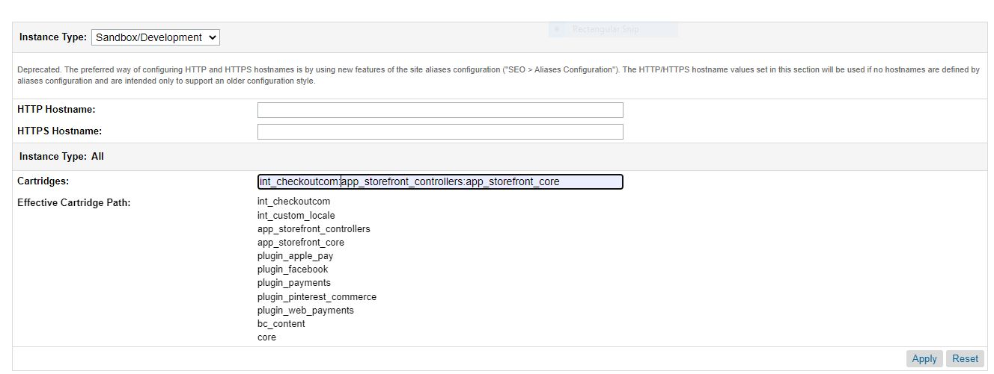

1. Go to **Administration > Site Development > Site Import & Export** to import the XML files available in the **metadata** folder.

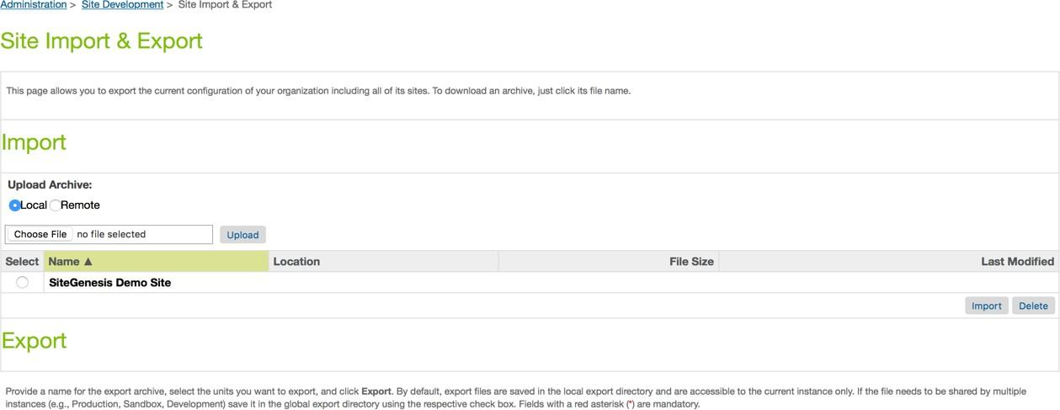

Once in the Site Import section, follow the steps below to import the metadata folder:

* + Open a file browser (e.g. Windows Explorer in Windows) and locate the metadata folder of the cartridge. Step down the folder hierarchy until you are in the subfolder “sites”. Re-name the contained folder “SiteGenesisGlobal” to the name of the site for which you want to import **int_checkoutcom** settings, payment methods and services.
  + Navigate back to the project’s root folder and create a zip **metadata.zip** out of the folder metadata.
  + Login to Business Manager and go to **Administration > Site Development > Site Import & Export**
  + Go to the section “Upload archive”. Choose “local” and click on the Browse button
  + Navigate in the file system, select the **metadata.zip** then click on “Open” and upload the zip file.
  + Check the import status in the Status section.

After the import has been completed successfully, all required Checkout.com data will be available globally and for the selected sites.

NOTE : - There is an additional configuration required for the checkout.com card payments.

We have to manually add “Checkout.com Card” as a processor in “CREDIT_CARD” payment method to make it work for the CHECKOUTCOM card payments.

* 1. **Custom Code**

1. In order to show the Checkout.com Site Genesis payment option on the billing page, the template **/app_storefront_core/cartridge/templates/default/checkout/billing/ paymentmethods.isml** has to be modified accordingly.

Add the following code snippet to the paymentmethods.isml template file:



The code above will display the Checkout.com payment form if enabled.

Please note that the Checkout.com payment form is not compatible with the default Site Genesis payment form. Please disable the default credit card form if using the Checkout.com payment form and vice versa.

1. In order to call the COPlaceOrder controller in site genesis the script **/app_storefront_controllers/cartridge/scripts/app.js** has to modified accordingly.

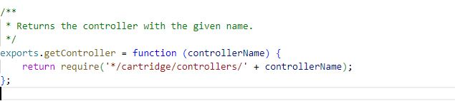

* 1. **External Interfaces**

The Checkout.com service endpoints are the external interface that this integration connects to. The documentation for the web service requests and responses can be found in the **charge with full card** section of the Checkout.com documentation.

* 1. **Firewall Requirements**

There are no specific firewall requirements.

* 1. **Testing**

In order to test the payment workﬂow in sandbox mode, Checkout.com provides a set of card numbers allowing to simulate multiple payment cases.

Use any future expiry date (mm/yy) with these test cards.

| **CARD** | **NUMBER** | **CVV** |
| --- | --- | --- |
| Visa | 4242424242424242 | 100 |
| Visa | 4543474002249996 | 956 |
| MasterCard | 5436031030606378 | 257 |
| MasterCard | 2223000010479399 | 299 |
| MasterCard | 5199992312641465 | 010 |
| AMEX | 345678901234564 | 1051 |
| AMEX | 378282246310005 | 1000 |
| Diners Club | 30123456789019 | 257 |
| JCB | 3530111333300000 | 100 |
| Discover | 6011111111111117 | 100 |

1. **Operations, Maintenance**
   1. **Data Storage**

No custom objects are created by this cartridge.

* 1. **Availability**

The Checkout.com payment gateway is expected to have continuous availability. The Checkout.com Payment Gateway API provides a 99.99% uptime SLA.

In case of unavailability of the service, shoppers might see their payment attempts declined. The unavailability of the checkout.com Gateway services will however have no impact on your SFCC site. All storefront and business manager features will remain accessible and usable.

In case of unavailability of the service, please send an email to [support@checkout.com.](mailto:support@checkout.com)

* 1. **Translation**

This Checkout.com cartridge is provided with the English language by default. It’s however possible to add custom translations for any language, using the translation files available in the resources folder.

* 1. **Support**

For questions regarding an account, contact your Checkout.com account manager or send an email to [support@checkout.com.](mailto:support@checkout.com)

1. **User Guide**

* 1. **Roles, Responsibilities**

There are no recurring tasks to be perform in order to run the Checkout.com Site Genesis cartridge integration.

* 1. **Business Manager**

The configuration parameters of the Checkout.com Site Genesis cartridge are available in: **Merchant Tools > Site Preferences > Custom Preferences**.

The following configuration screens are available:

1. **CKO [1] Sandbox Keys**

The Checkout.com sandbox API credentials. A private key, a public key and a private shared key for the ABC and NAS platform and also included a custom preference for the ABC\NAS enabled.

If you want to use the ABC keys then choose ABC from the dropdown, else choose NAS. The default value for the custom preference is ABC.

These credentials allow your online store to connect and communicate with the sandbox/test payment gateway.

They will be available in your Checkout.com account once it’s been opened by your Account Manager. Please see the Contact section for more information on how to contact Checkout.com.

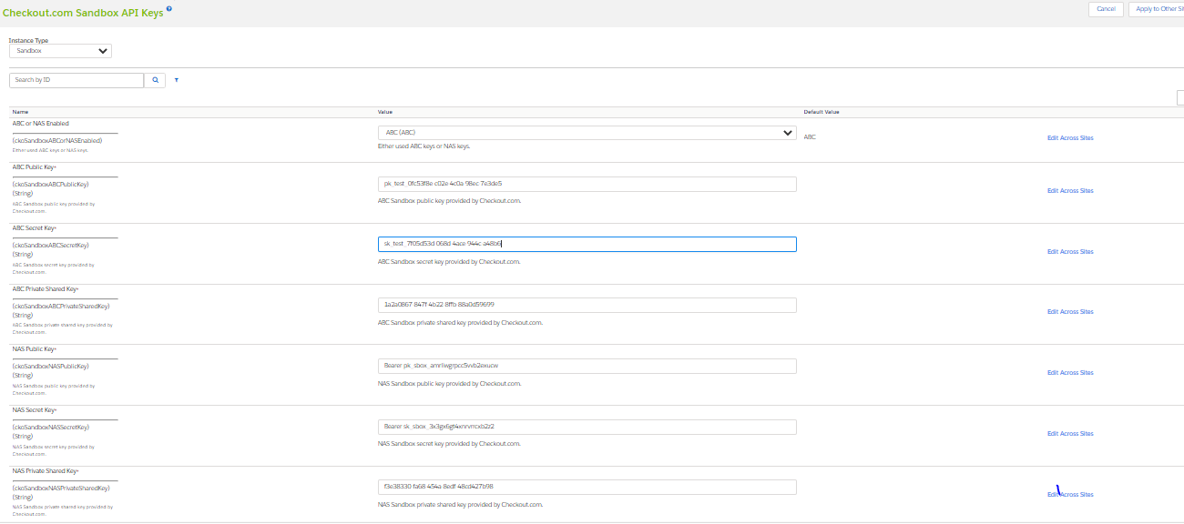

1. **CKO [2] Live Keys**

The Checkout.com live API credentials. A private key, a public key and a private shared key for the ABC and NAS platform and also included a custom preference for the ABC\NAS enabled.

If you want to use the ABC keys then choose ABC from the dropdown, else choose NAS. The default value for the custom preference is ABC.

These credentials allow your online store to connect and communicate with the live/production payment gateway.

They will be available in your Checkout.com account once it’s been opened by your Account Manager. Please see the Contact section for more information on how to contact Checkout.com.

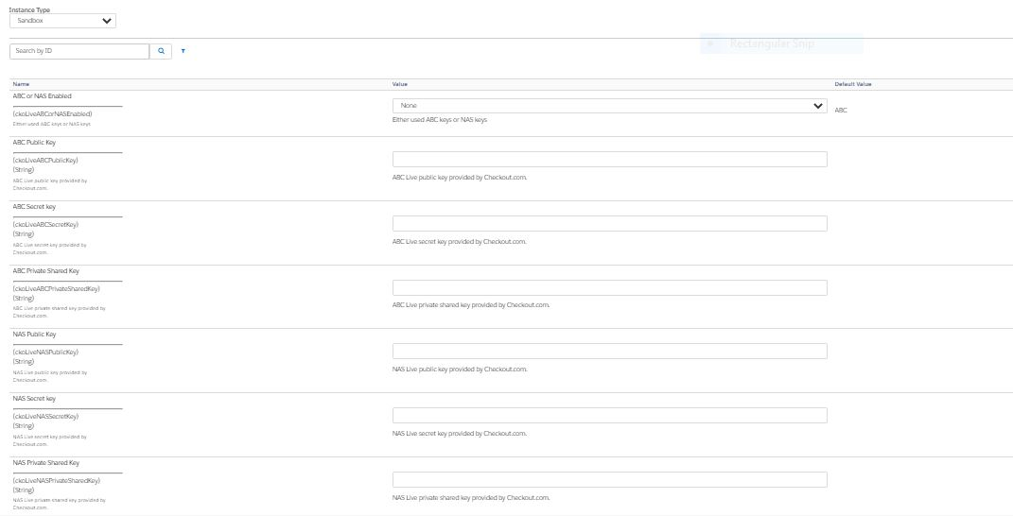

1. **CKO [3] Business Details**

The legal address and billing descriptors for your online store.

1. **CKO [4] Payment Settings**

The Checkout.com gateway global payment settings and card payment settings. The following parameters are available.

* + **Enable**

Enables the Checkout.com cartridge. This preference is used to enable the checkout.com integration on site.

* + **Enable debug mode**

When the debug mode is enabled, the cartridge will log all gateway response in the log files of your website.

* + **3D Secure**

Should 3D Secure be active

* + **Attempt Non 3D Secure**

In case of failure of a 3D secure check, should the gateway try to fallback to a regular transaction without 3D Secure check.

* + **Auto capture**

After authorisation, should the transaction be captured immediately or with a delay.

* + **Auto capture time**

An integer or decimal number specifying how long after the authorisation the capture should happen.

Time provided in minutes. Ex: A provided time of 0.2 minutes corresponds to 12 seconds between the initial card authorisation and the capture.

It’s recommended to avoid setting the auto capture time to 0, in order to avoid collision between the authorisation confirmation and the capture confirmation.

* + **Enable MADA Payment Cards**

Enable payments with mada cards in the middle east.

* + **Checkout MADA Bins**

This preference is used to store the mada cards bin in json format for Appla Pay and Cards.

1. **CKO [5] APM Settings**

The Checkout.com Alternative Payment Methods settings.

This section is used to enable the APM payment methods that you want to add on your store.

1. **CKO [6] Google Pay Settings**

For google pay setup follow the guide of google pay on checkout.com, the link is :-

https://www.checkout.com/docs/payments/payment-methods/wallets/google-pay

The Checkout.com Google Pay payment method settings.

⦁ **Enable Google Pay**

Enable the google pay on your site.

⦁ **Environment**

Should the Google Pay option run in test or production mode.

⦁ **Google Pay merchant ID**

Enable payments with Google Pay.

⦁ **Button Style**

This preference is to decide the google pay button color.

⦁ **Enable 3D Secure For Google Pay**

Enable payments with Google Pay using 3D Secure authentication.

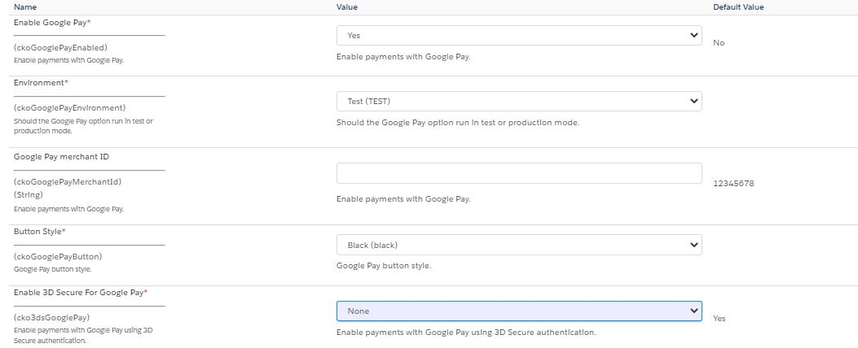

1. **CKO [7] Apple Pay Settings**

For apple pay setup follow the guide of apple pay on checkout.com, the link is :- https://www.checkout.com/docs/payments/payment-methods/wallets/apple-pay

The Checkout.com Apple Pay payment method settings.

⦁ **Enable Apple Pay**

Enable the Apple pay on your site.

⦁ **Environment**

Should the Apple Pay option run in test or production mode.

⦁ **Apple Pay merchant ID**

Enable payments with Apple Pay.

⦁ **Button Style**

This preference is to decide the apple pay button color.

* 1. **Storefront Functionality**

Once enabled, the Checkout.com Site Genesis integration will add a new functionality to your Salesforce Commerce Cloud store.

The Checkout.com Card payments, Apple Pay payments, Google Pay payments and Alternative Payment methods will show as payment options on the billing page.

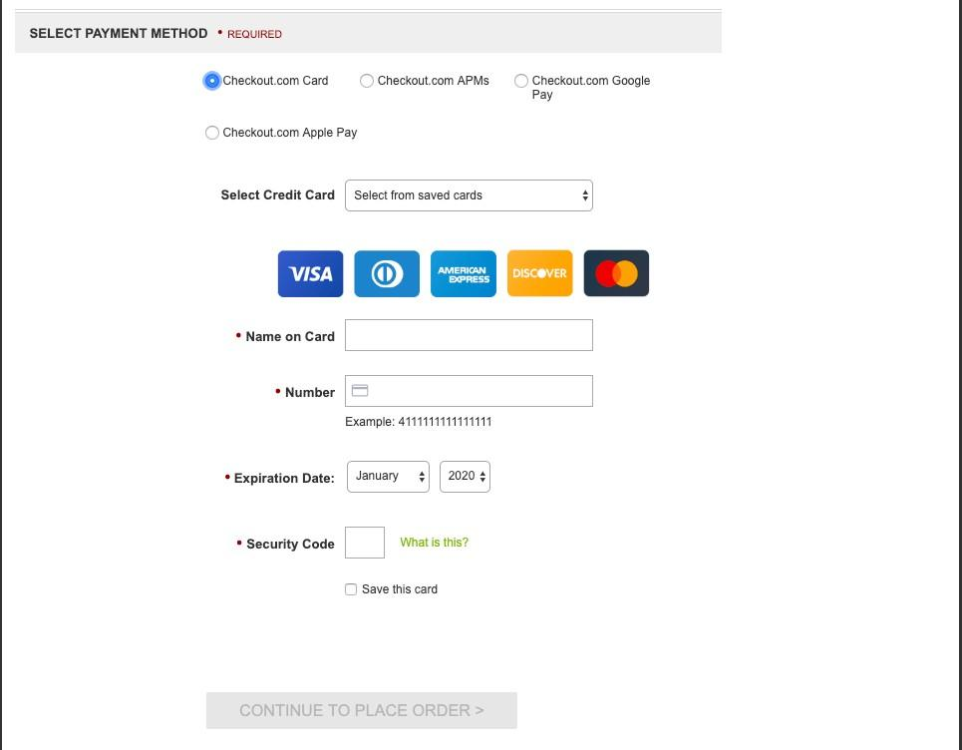

After having option a payment option and provided payment details, the shopper can go to order review page

Clicking on the “Place Order” button will send a charge request to the Checkout.com payment server, without having to redirect the shopper.

In case of successful payment, the shopper will be redirected to the order confirmation page.

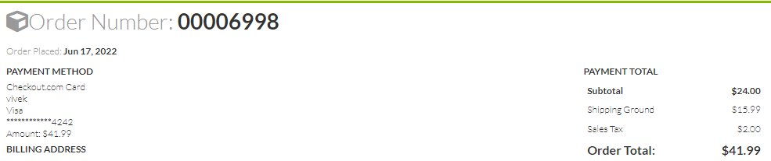

**6.** **Known Issues**

No known issues at this time.